 |  |  | EAST FORK FIRE PROTECTION DISTRICT  1694 County Road  Minden, Nevada 89423  (775) 782-9040

PURPOSE
The intent of this guideline is to provide the requirements for the protection of high-piled storage (HPS) for a variety of commodities. HPS increases the potential fire hazard within a structure by increasing the vertical height of storage and by providing stability of storage (e.g., rack and automated storage) in a fire situation. The following requirements will ensure that the minimum measures required by code have been taken to provide for the public safety and that the required protection of these commodities has been designed in accordance with Chapter 32 of the 2024 International Fire Code (IFC), the 2024 International Building Code(IBC) and locally adopted Regulations enforced by East Fork Fire Protection District (EFFPD).

SCOPE
This guideline provides the requirements for all HPS within the jurisdiction of EFFPD.

DEFINITIONS

High-Piled Combustible Storage (HPS)
The storage of combustible materials in closely packed piles, on pallets, in racks, or on shelves where the top of storage is greater than 12 feet in height. High-piled combustible storage also includes certain high-hazard commodities, such as rubber tires, Group A plastics, flammable and combustible liquids, idle pallets, and similar commodities where the top of storage is greater than 6 feet in height. (IFC 202)
Note: To be considered non-high pile combustible storage for high hazard commodities < 6 feet, there cannot be any storage above it.

Max 6’

High Hazard Commodity

Class I-IV Commodities

High-Piled Storage Area
An area within a building that is designated, intended, proposed, or actually used for high-piled combustible storage, including operating aisles. For purposes of selecting the applicable fire protection requirement row in Table 3206.2:

- This area shall include the “footprint” of the actual storage array (racks, shelves, fixtures, or pallets), inclusive of aisles within the storage area(s). When individual storage arrays are separated by less than 15-foot spaces, the spaces shall be considered aisles and shall be included in a single storage area footprint.

- Where a building contains multiple high-piled storage areas, the aggregate of all high-piled storage areas shall be used for the application of Table 3206.2 unless the high-piled storage areas are separated in accordance with one of the following:
  - High-piled storage areas separated by fire barriers with a minimum fire-resistance-rating of 1 hour constructed in accordance with Section 707 of the International Building Code.
  - In buildings equipped throughout with an automatic sprinkler system in accordance with Section 903.3.1.1, high-piled storage areas separated by 100 feet (30 480 mm) or more. The area providing the separation shall not contain high-piled combustible storage.

Rack Storage
A combination of vertical, horizontal, and diagonal members that support stored materials. Racks can be fixed or portable. NFPA 13 Section 3.3.177.
Open Rack
Racks without shelving or with shelving in racks that are fixed in place with shelves having a solid surface and shelf area equal or less than 20 ft² or with shelves having a wire mesh, slatted surface, or other material with openings representing at least 50 percent of the shelf area including the horizontal area of the rack members and where the flue spaces are maintained.

Shelf Storage
Storage on structures up to and including 30 in. (750 mm) deep and separated by aisles at least 30 in. For larger shelves and other storage arrangements see Rack Storage. 2022 NFPA 13 Section 3.3.196

Solid Shelving
Shelving that is fixed in place, slatted, wire mesh, or other type of shelves located within racks. The area of a solid shelf is defined by perimeter aisle or flue space on all four sides or by the placement of loads that block openings that would otherwise serve as the required flue spaces. Solid shelves having an area equal to or less than 20 ft² (1.9 m²) are defined as open racks. Shelves of wire mesh, slats, or other materials more than 50 percent open and where the flue spaces are maintained are defined as open racks. NFPA 13 Section 3.3.209

Mesh, grated, slated, and similar shelves having uniform openings not more than 6 inches apart and comprising not more than 50% of the overall shelf area, and provided with approved flue spaces are allowed to be treated as racks without solid shelving. If the item stored within the rack has a horizontal area that exceeds 20 ft² in size the shelf is considered solid regardless of the construction of the shelf. As an example, the HPS uses wire mesh shelves with an opening greater than 50%. The commodity being stored is on a non-standard pallet of 4’ deep by 6’ wide, total horizontal size = 24 ft². The shelving would be considered solid since the commodity exceeds 20 ft² irrespective that the shelf is wire mesh.

SUBMITTAL REQUIREMENTS

General
At the time of permit application, plans and specifications, including but not limited to the information listed below, shall be submitted for review and approval. HPS projects require the services of a design professional with a
comprehensive understanding of the requirements contained in IFC Chapter 32 and NFPA 13. EFFPD requires a qualified fire protection engineer (FPE) to evaluate the proposed storage commodities, storage methods, and develop the fire sprinkler design criteria. A technical report prepared by the FPE shall describe the basis for determining the commodity and fire sprinkler design. This report shall include references to design documents and accompany the HPS plan submittal.

All plan submittals and revisions must be electronically submitted via the EFFPD plan portal: https://eastforktahoedouglas.geocivix.com/ Plans shall contain the following information per IFC 3201 Items A - R below:
  - A letter of intent containing a detailed description of the products to be stored and the description of all containers, pallets, and packaging materials. This letter must also include a detailed description of the storage methods (racks, shelves, or pallets), the total storage area in square feet, maximum storage height, and aisle widths. An authorized officer of the company or business must sign this letter. The letter shall be copied onto the plans.

  - A scaled site plan that shows the entire building, including all fire access lanes, fire hydrants, fire department connection, and fire sprinkler risers. IFC 3206.6.
  - A scaled floor plan of the building showing locations and dimensions of the HPS area, location of the racks, access doors to the storage area, fire sprinkler risers, and FACU.
  - The maximum desired/proposed storage height for each designated storage area per array. This height is measured from the finished floor to the highest point of the commodity stored (not shelf level).
  - The number of tiers within each rack.

  - The commodity clearance between the top of storage and the sprinkler deflector for each storage arrangement.
  - Aisle dimensions between each storage array. Aisles are measured from the actual edge of the commodity to commodity, not rack to rack.

  - Maximum pile volume for each storage array for solid pile and shelf-storage.
  - The location and classification of different commodity classes. In sprinklered buildings with multi-tenant spaces, where the HPS area is less than 12,001 ft² and the building does not have access doors spaced per IFC 3206.7 and smoke & heat vents are not provided, the plan shall show one of the following:

    - Based upon a building survey and evaluation, identify the presence of a full height wall between the adjacent tenant space is a minimum of a one-hour fire barrier per IBC Section 707, or

    - Identify all HPS areas in all adjacent tenant spaces. The aggregate of all areas of HPS within the building shall be used to determine fire protection and life safety features per Table 3206.2. The protection required by Table 3206.2 will be based on the individual HPS areas commodity classification and extend to the lesser of 15 feet in all directions, or to a full height partition.
In sprinklered buildings with multi-tenant spaces, where the HPS area is > 12,000 ft² the plan only needs to show the protection and life safety requirements per Table 3206.2 for the new HPS area.
  - The location of commodities that are banded (for rolled paper) or otherwise encapsulated.

  - The dimension and location of the transverse and longitudinal flue spaces.

  - Identify the sprinkler design. The sprinkler design requirements are based on commodity type, aisle width, and sprinkler temperature rating as outlined in 2022 NFPA 13, Chapter 21 (e.g., .45/3000 with 286-degree heads, with a K Factor of 5.5). A complete sprinkler design shall be submitted under a separate permit.
If the sprinkler design is only provided for the HPS area while the surrounding sprinklers are of a different design, identify the sprinkler protection area for the HPS; ensure the protection extends the lesser of 15 feet in all direction or to a full height partition. NOTE: The 15 feet begins at the outer most portion of the required aisle as set forth in IFC 3206.2.1.

  - The location of all steel columns in relationship to the racks. All steel columns located within a rack flue space or immediately adjacent to a rack in an aisle may require protection. See 2022 NFPA 13, Sections 16.1.4, 17.1.4, or 18.2.1.
  - The location, make, model, type, and automatic link temperature of the automatic/manual release smoke vents, if vents are required or provided. In sprinklered buildings, the fusible links for smoke and heat vents shall operate at a temperature rating of 360 degrees. IFC 910.3.5

An inspection report by the inspecting contractor shall be provided to EFFPD inspector at the time of final inspection. The report, at a minimum, shall identify the year the building was constructed, a roof plan showing the location of each vent inspected, the fusible link temperature rating, the presence of a manual release mechanism, and the operational status of each vent. Prior to submitting the report to the inspecting authority, all identified deficiencies must be corrected and included within the report.

If the existing smoke vents do not contain manual release devices, and EFFPD determines that the manual release devices were not specifically required at the time of original construction or during any previously approved high piled storage use, then manual release devices will not be required. EFFPD staff will evaluate existing conditions on a case-by-case basis during the review process.

  - The occupancy group as defined by IBC Chapter 3 and approved by the Building Official.
  - Pallet/commodity stop details for maintaining the required flue space (see attachment 2-5 for suggested methods), other proposed methods will be evaluated for approval.

  - EFFPD requires High Pile Storage Minimum Information Form (Attachment 9) completed and copied onto the first sheet of the HPS plan.
  - A plan view and elevation view of pallet stop/s for both transverse and longitudinal flue spaces.

International Fire Code Permits—IFC 105.6.4
Plans and specifications shall be submitted to the EFFPD as indicated elsewhere in this document. All permits will be issued following plan approval and completion of corresponding inspections of the HPS installation. An IFC permit is required when a building or portion thereof is used for high-piled storage exceeding 500 square feet in area (see the definition of high-piled storage area under “Scope”).

Commodity Classification—IFC 3203
Commodities shall be classified as Class I, II, III, IV, or High Hazard, in accordance with IFC Chapter 32 and referenced standards.
Plastics shall be classified as Group A, B, or C in accordance with IFC Chapter 32. To determine the proper commodity classification of products with limited quantities of Group A plastics in mixed commodities, use IFC Figure 3203.9 (1 & 2) This figure identifies the quantity of Group A plastics allowed to be stored in a package, carton, or on a pallet without increasing the hazard and commodity classification to “high hazard”.

The designation and protection features of a high-piled combustible storage area intended for storage of different commodity classes shall be based on the highest hazard commodity stored, except as otherwise provided for by engineering analysis in IFC 3204.2.
Note: Flammable liquids, flammable solids, flammable gasses, aerosols, explosives, oxidizers, and reactive materials, etc. fall under the category of hazardous materials and additional code requirements apply. Storage of hazardous materials generally require submittal and approval of additional hazardous materials plans prior to further review of the high-piled storage plan.

General Fire-Protection Provisions—IFC 3206
Fire-protection features for high-piled storage areas shall be in accordance with IFC Chapter 32 and other nationally recognized standards approved by RFFPD. Fire-detection systems, smoke and heat removal, and fire sprinkler design densities shall extend to 15 feet beyond the high-piled storage area or to a permanent partition, whichever is least (IFC 3206.2.1). The aggregate of all high-piled storage areas within a building shall be used to design the fire protection features found in IFC Table 3206.2 (attached), unless such areas are separated from each other by a one-hour fire barrier wall constructed in accordance with IBC 707. Distinct occupancy groups shall also be separated according to IBC 508.

Fire Sprinkler Systems—IFC 3206.4
When fire sprinklers are required by IFC Table 3206.2 or the IBC (or if otherwise provided), the sprinkler system shall be installed in accordance with 2022 NFPA 13, or other applicable NFPA codes. A full description of the applicable tables, figures, and curves in NFPA 13, Chapters 12 – 26 (Storage) to determine the design criteria.

Fire Detection Systems—IFC 3206.5
When fire detection is required by CFC Table 3206.2, an approved automatic fire detection system shall be installed in accordance with 2022 NFPA 72 standard throughout the high-piled storage area. This system shall be installed and monitored as required by CFC 907.

Fire Department Access—IFC 3206.6, 3206.7
When building access is required by IFC Table 3206.2, access roadways shall be provided to within 150 feet of all portions of the exterior walls of the building used for high-piled storage. When access doors are required by IFC Table 3206.2, they shall be provided in each 125 lineal feet or faction thereof, of the exterior wall that faces the required access roadway, measured center of door to center of door.

The linear distance between adjacent access doors shall not exceed 200 feet (60 960 mm) in existing buildings where a change in occupancy is not proposed. The exterior side of each access door shall be provided with a durable sign stating: FIRE DEPARTMENT ACCESS DOOR- DO NOT BLOCK. Letters shall be of a contracting color to the background and have a minimum height of 2” and minimum stroke of 3/8”.

Smoke and Heat Removal—IFC 3206.8
When smoke and heat removal are required by IFC Table 3206.2, smoke and heat vents shall be of an approved type and shall operate automatically by a heat response device and contain a manual release roof handle. Vent size shall be in accordance with IFC 910.3 (Equations 9-3 & 9-4, see below) The fusible link temperature shall be rated as specified in Section 1-N of this Guideline. Smoke and heat vents are not required when storage areas with an exit access travel distance of 250 feet or less and protected by early suppression fast response (ESFR) sprinkler systems installed in accordance with NFPA 13. Smoke vents shall be inspected and maintained in accordance with NFPA 204.

Equation 9-3
Sprinklered Buildings AVR= V/9000
Where:
AVR = The aggregate vent area (ft²)
V = Volume (ft³) of the area that requires smoke removal.

Equation 9-4
Non-Sprinklered Buildings AVR= V/50
Where:
AVR = The aggregate vent area (ft²)
V = Volume (ft³) of the area that requires smoke removal.

Rack Flue Spaces—IFC 3208.3
Requirements for flue spaces within the rack storage are provided in IFC Table 3208.3 (See Attached). Single and double row racks shall be equipped with a transverse flue space. Either a mechanical means shall be provided to maintain the transverse flue space, OR the load beam shall be painted with a 3-inch yellow strip with the words in red that read, “Keep Clear”, as indicated below. Durable vinyl tape or other appropriate material may be used in lieu of paint, or other methods as approved by EFFPD. In double row racks where only transverse flue space are provide per Table 3208.3, or where multi-row racks are provided, mechanical means for maintaining the flue space shall be provided.

Rack Face
3”-6”
Keep Clear
Reference Table 3206.8 for arrangement and minimum flue width.

Double-row racks shall be equipped with a pallet/commodity stop or other flue protection method approved by EFFPD to maintain the required longitudinal flue space at each level (IFC 3208.3.1). Suggested methods include; providing a stop along the longitudinal flue space which may be steel or other ferrous material ¼” thick and, in the mounted position, extend 4 inches above the shelf or cross member. Another suggested method is to provide a chain link barrier. In double row racks, where products are hand-stacked, chain link may be attached securely attached to the rear of both racks. (See Attachments 1- 8 for additional suggestions and details) Other methods may be approved by EFFPD.
Suggested designs are outlined in Attachments 1 through 7. If a design outlined in one or more of the attachments is used, the appropriate detail or details shall be copied onto the plan.
NOTE: Regardless of the design of the pallet stop or other flue protection device, the flue space shall be measured from the back of the pallet stop or other device to the back of the opposing pallet stop or other device. (See Attachment 8)

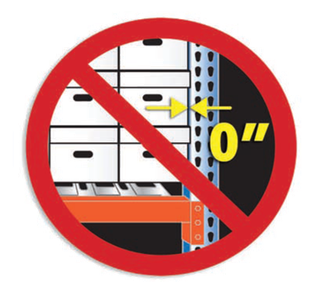
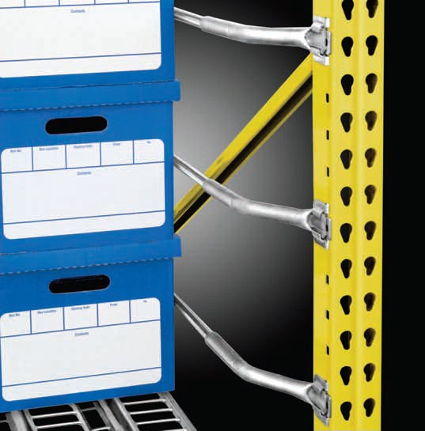
Transverse flue space is measured as the distance between the loads, not the distance between the racks. A flue space's net width is a measure of its gross width minus any horizontal obstructions, such as rack uprights, located within the flue space. In other words, a rack upright (typically 3 in. wide) is not considered a flue space, due to the cross bracing used.

Acceptable Method

Solid Piled and Shelf Storage
Shelf storage, storage in solid piles, solid piles on pallets, and storage in bin boxes not exceeding five feet in any dimension shall be in accordance with IFC 3206 and 3207.

Rack Storage
Rack storage in both fire sprinklered and non-sprinklered buildings shall be in accordance with IFC 3206 and 3208. The fire sprinkler protection for racks with solid shelves shall be based on IFC definition for solid shelves.

Automated Storage
Automated storage similar to carousel storage shall be in accordance with IFC 3209.

Specialty Storage—IFC 3210
Record storage facilities used for rack or shelf storage of combustible paper records greater than 12 feet in height shall be in accordance with IFC 3206, 3208, and NFPA 13. Palletized storage of records shall be in accordance with IFC 3207.

MAINTENANCE

IFC Chapter 9
All fire and life safety equipment and systems required by the IFC shall be maintained operable at all times. Equipment, devices, and systems shall be regularly tested in accordance with nationally recognized standards, manufacturers’ recommendations, and adopted regulations.
The responsibility for inspections, maintenance of the HPS areas as approved, and all fire and life safety equipment and systems required by the IFC shall be the ultimate responsibility of the building owner provided that this responsibility has not been transferred in written form to a management company or other party via a lease agreement or other legal document.

DO NOT STORE ABOVE THE YELLOW LINE
Note: Where required by the fire code official, a visual method of indicating the maximum allowable storage height shall be provided. IFC 3205.7

APPROVED PLANS IFC Chapter 3201.3
A copy of the approved HPS plans shall be signed by the EFFPD Inspector upon completion of final inspection and shall be protected under clear plastic or glass AND permanently affixed to a designated wall in a prominent location within the warehouse as approved by the EFFPD Inspector. An Operational Permit will also be issued by the EFFPD Inspector. The permit shall be posted in a prominent location. A copy of the approved plans shall be maintained on site for the life of the HPS system. EFFPD shall be consulted prior to any changes in the approved/existing/permitted HPS system(s).

TECHNICAL ASSISTANCE
HPS projects require the services of a design professional with a comprehensive understanding of the requirements contained in IFC Chapter 32 and NFPA 13. EFFPD requires a qualified fire protection engineer (FPE) to evaluate the proposed storage commodities, storage methods, and develop the fire sprinkler design criteria. A technical report prepared by the FPE shall describe the basis for determining the commodity and fire sprinkler design. This report shall include references to design documents and accompany the HPS plan submittal. (IFC 104.2.2, 3204.2)

TABLE 3206.2: GENERAL FIRE-PROTECTION AND LIFE-SAFETY REQUIREMENTS
Commodity Class | Size of High-Piled Storage Area ª (square feet) (See Sections 3206.2 and  3206.4) | ALL STORAGE AREAS (See Sections 3206, 3207 and 3208) ^{b} |  |  |  | SOLID-PILED STORAGE, SHELF STORAGE AND PALLETIZED STORAGE (See Section 3207.3)
Commodity Class |  | Automatic Fire-extinguishing System (See Section 3206.4) | Fire-detection System  (See Section 3206.5) | Fire department Access Doors (See Section 3206.7) | Smoke and Heat Removal (See Section 3206.8) | Maximum Pile Dimension ^{c} (Feet) | Maximum Permissible Storage Height ^{d} (feet) | Maximum Pile Volume (cubic feet)
 | 0-500 | NR ª | NR | NR | NR | NR | NR | NR
 | 501-2,500 | NR ª | Yes ^{g} | NR | NR | 120 | 40 | 100,000
 | 2,501-12,000 | Yes | NR | NR | NR | 120 | 40 | 400,000
 | Public
 | Accessible
 | 2,501-12,000
I-IV | Nonpublic Accessible  (Option 1) | Yes | NR | NR | NR | 120 | 40 | 400,000
 | 2,501-12,000
 | Nonpublic  Accessible | NR ª | Yes | Yes | Yes h, i | 120 | 30 ^{e} | 200,000
 | (Option 2)
 | 20,001- | Yes | NR | Yes | Yes h, i | 120 | 40 | 400,000
 | 500,000
 | 500,000+ | Yes | NR | Yes | Yes h, i | 120 | 40 | 400,000
 | 0-500 | NR ª | NR | NR ^{e} | NR | 60 | NR | NR
 | 501-2,500 | Yes | NR | NR ^{e} | NR | 60 | 30 | 75,000
 | Public
 | Accessible
 | 501-2,500
 | Nonpublic  accessible | Yes | NR | NR ^{e} | NR | 60 | 30 | 75,000
High-hazard | (Option 1)
High-hazard | 501-2,500
 | Nonpublic  accessible | NR ª | Yes ^{g} | Yes | Yes h, i | 60 | 20 | 50,000
 | (Option 2)
 | 2,501- | Yes | NR | Yes | Yes h, i | 60 | 30 | 75,000
 | 300,000
 | 300,000 ^{f}- | Yes | NR | Yes | Yes h, i | 60 | 30 | 75,000
NR = Not Required
a When fire sprinklers are required for reasons other than those in Chapter 32, the portion of the sprinkler system protecting the high-piled storage area shall be designed and installed in accordance with Sections 3207 and 3208.
b For aisles, see Section 3206.10.
c Piles shall be separated by aisles complying with Section 3206.10.
d For storage in excess of the height indicated, special fire protection shall be provided in accordance with Footnote f when required by the fire code official. See also Chapters 51 and 57 for special limitations for aerosols and flammable and combustible liquids.
e For storage exceeding 30 feet in height, Option 1 shall be used.
f Special fire-protection provisions including, but not limited to, fire protection of exposed steel columns; increased sprinkler density; additional in-rack sprinklers, without associated reductions in ceiling sprinkler density; or additional fire department hose connections shall be provided when required by the fire code official.
g Not required when an automatic fire-extinguishing system is designed and installed to protect the high-piled storage area in accordance with Sections 3207 and 3208.
h Not required where storage areas are protected by either early suppression fast response (ESFR) sprinkler systems or control mode special application sprinklers with a response time index of 50 (m • s)1/2 or less that are listed to control a fire in the stored commodities with 12 or fewer sprinklers, installed in accordance with NFPA 13.
i Not required in frozen food warehouses used solely for storage of Class I and II commodities where protected by an approved automatic sprinkler system.

TABLE 3208.3: REQUIRED FLUE SPACES FOR RACK STORAGE
RACK CONFIGURATION | Flue Design |  | AUTOMATIC SPRINKLER PROTECTION
RACK CONFIGURATION |  |  | SPRINKLER AT THE CEILING WITH OR  WITHOUT MINIMUM IN-RACK SPRINKLERS |  | IN-RACK SPRINKLERS AT EVERY TIER
RACK CONFIGURATION |  |  | Storage Height ≤ 25 feet | Storage Height > 25 feet | Any Height
Single-row Rack | Transverse Flue Space | Size ^{b} | 3 inch | 3 inch | NR
Single-row Rack | Transverse Flue Space | Vertically Aligned | NR | Yes | NR
Single-row Rack | Longitudinal Flue Space |  | NR | NR | NR
Double-row Rack (Option 1) | Transverse Flue Space | Size ^{b} | 6 inch ª | 3 inch | NR
Double-row Rack (Option 1) | Transverse Flue Space | Vertically Aligned | NR | Yes | NR
Double-row Rack (Option 1) | Longitudinal Flue Space |  | NR | 6 inch | NR
Double-row rack (Option 2) | Transverse Flue Space | Size ^{b} | 3 inch | 6 inch | NR
Double-row rack (Option 2) | Transverse Flue Space | Vertically Aligned | NR | Yes | NR
Double-row rack (Option 2) | Longitudinal Flue Space |  | 6 inch | NR | NR
Multi-row Rack | Transverse Flue Space | Size ^{b} | 6 inch | 6 inch | NR
Multi-row Rack | Transverse Flue Space | Vertically Aligned | NR | Yes | NR
Multi-row Rack | Longitudinal Flue Space |  | NR | NR | NR
NR = not required.
a Three-inch transverse flue spaces shall be provided at least every 10 feet where ESFR sprinkler protection is provided.
b Random variations are allowed, provided that the configuration does not obstruct water penetration.

ATTACHMENT 1

EXAMPLES OF LOAD BEAM CONFIGURATIONS NOT REQUIRING FLUE PROTECTION
102”
10”
46”
46”
102”
44”
14”
44”
102”
42”
18”
42”

NOTES:
- MAXIMUM PALLET DEPTH 48”
- STORAGE ON LOAD BEAM ONLY, NO SHELVING, WIRE MESH GRATING, OR PALLET SUPPORTS.
- 6” FLUE SPACE SHALL BE MAINTAINED AT ALL TIMES.

NOTES:
  - WHEN 42” UPRIGHTS ARE UTILIZED WITH AN 18” ROW SPACER AND A TYPICAL
48”x40” PALLET IS USED, NO PALLET STOPS ARE REQUIRED.
  - WHEN 44” UPRIGHTS ARE UTILIZED WITH A 14” ROW SPACER AND A TYPICAL 48”x40” PALLET IS USED, NO PALLET STOPS ARE REQUIRED.
  - WHEN 46” UPRIGHTS ARE UTILIZED WITH A 10” ROW SPACER AND A TYPICAL 48”x40” PALLET IS USED, NO PALLET STOPS ARE REQUIRED.

12
1/2026

ATTACHMENT 2

STORAGE CONFIGURATION REQUIRING FLUE SPACE PROTECTION
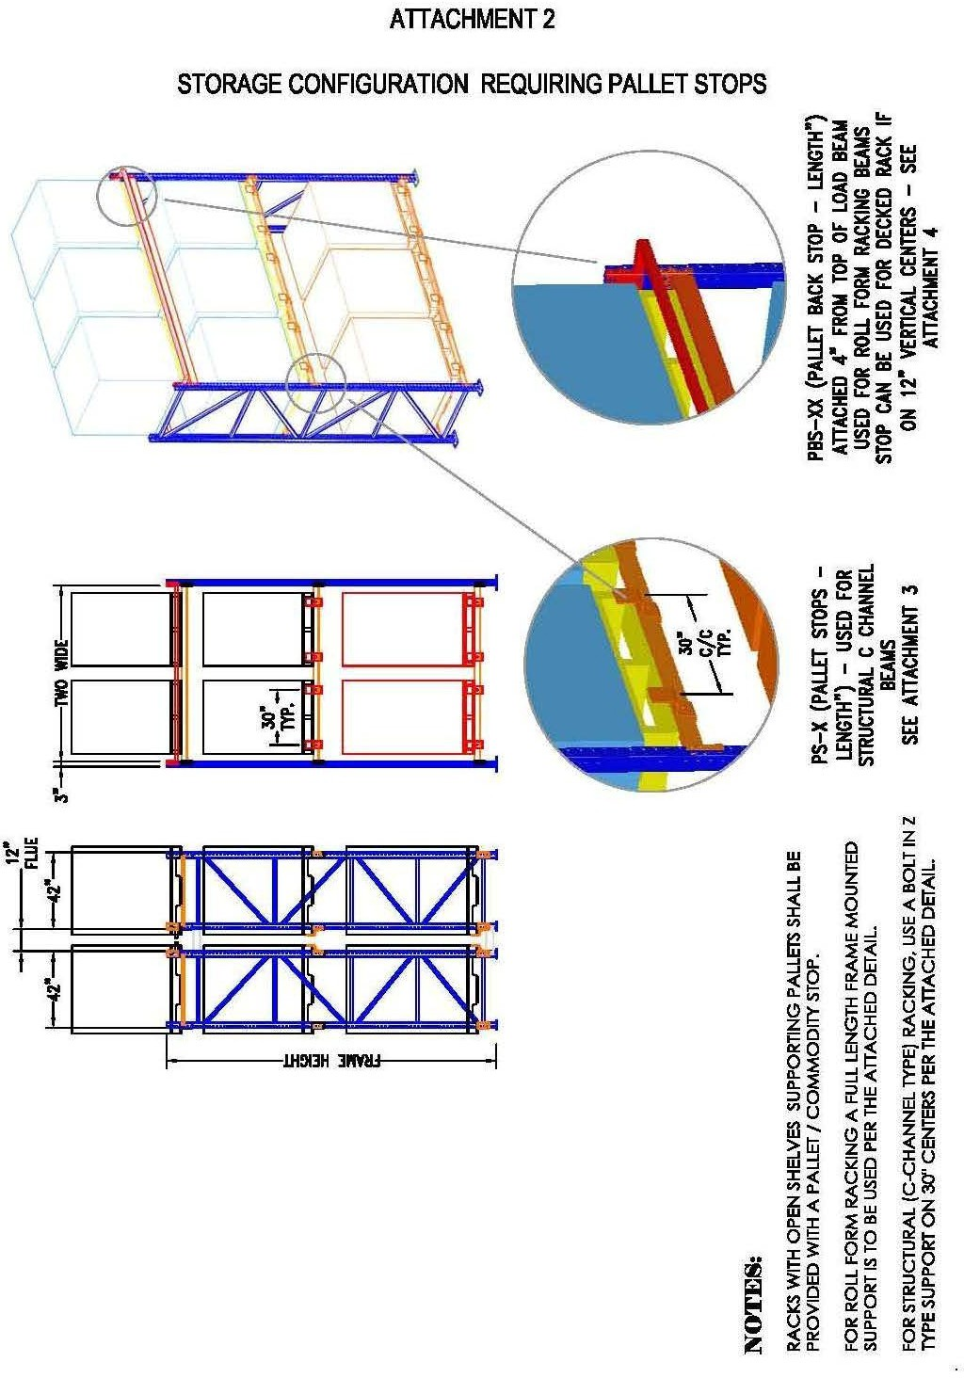

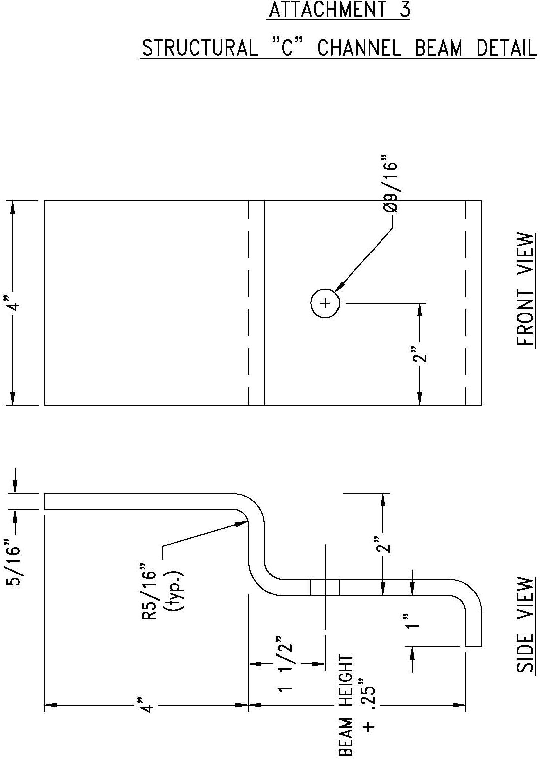

ATTACHMENT 3

STRUCTURAL “C” CHANNEL BEAM DETAIL

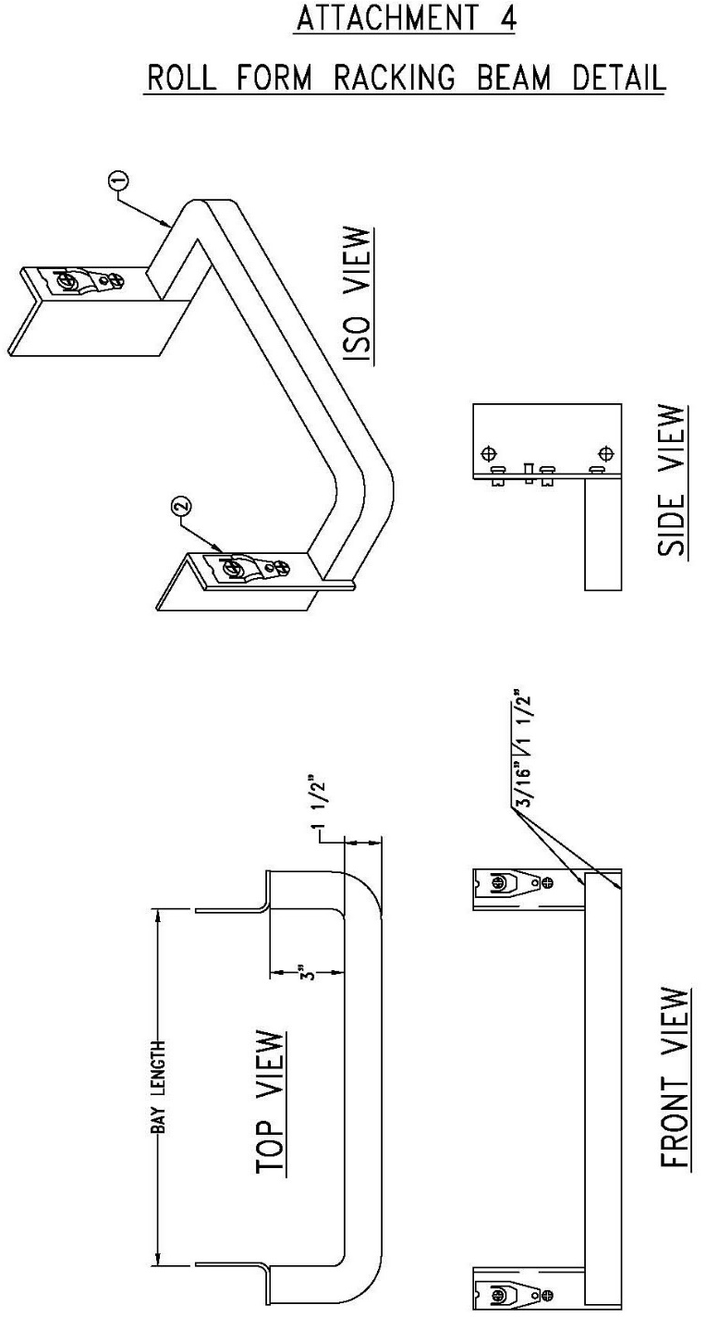
ATTACHMENT 4
ROLL FORM RACKING DETAIL

ATTACHMENT 5

Suggested Method for Maintaining Flue Space For Hand Stack Rack Storage Configuration

Pallet Stop



Load Beam

Fastener
(see Attachment 6)

NOTES:
HAND STACKING/PICKING RACKS: HAND STACKING
12 Gauge Chain Link for Hand Stack
9 Gauge Chain Link for Pallet

NON-PALLETIZED AREAS SHALL BE PROVIDED WITH A MEANS TO ENSURE THAT THE FLUE SPACES ARE MAINTAINED. HAND
STACK LOCATION WILL BE SECURED FLUSH TO THE REAR COLUMN OF EACH FRAME AS SHOWN IN ATTACHED DETAIL (SEE ATTACHMENT 6 FOR CHAIN LINK).
9 Gauge Chain Link Fence for Pallet Loads. 12 Gauge Chain Link for Hand Stack Loads.

ATTACHMENT 6

SUGGESTED CHAIN LINK ATTACHMENT METHOD DETAIL
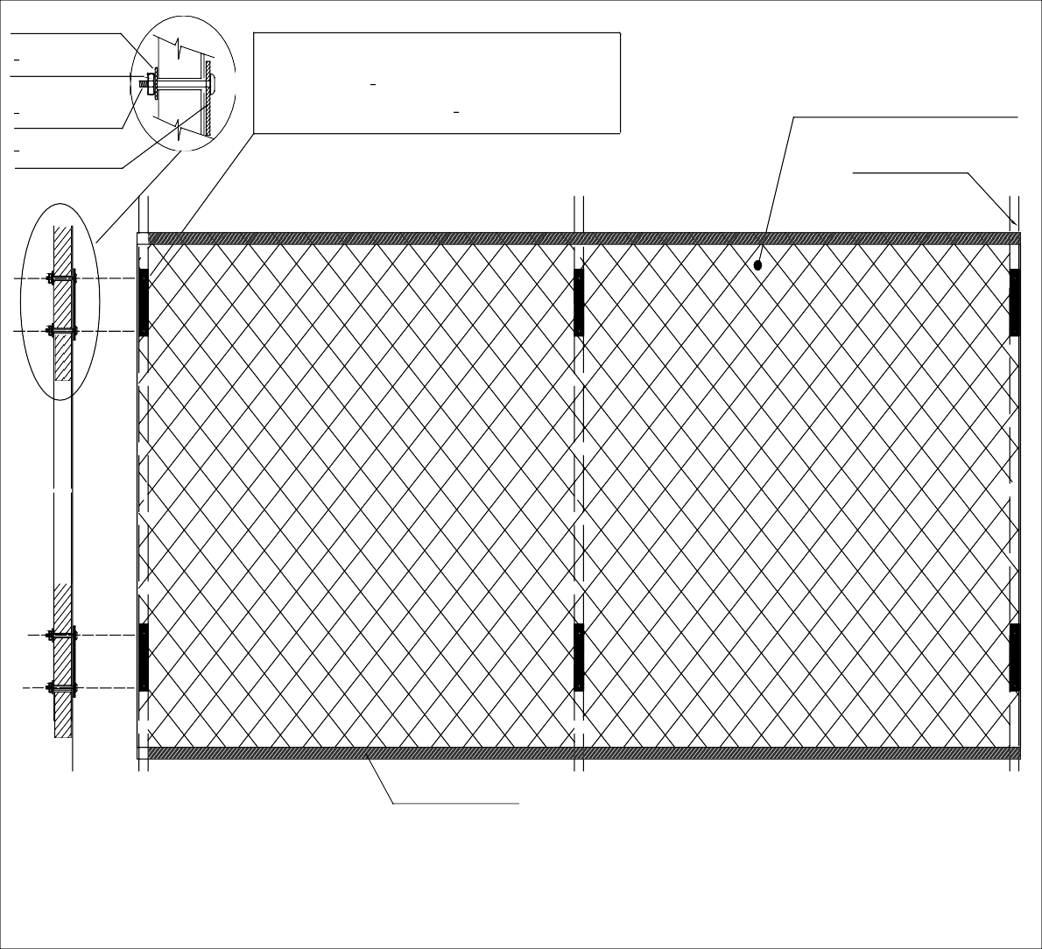
Chain link (or other approved method), secured firmly
to uprights thru. ¹" thk x 12" long steel plate at
8
maximum 48" o.c. and a min ³" bolt
8
Fender washer
8
³" Nut
₈" Bolt
3
Chain Link - 12 GA min
8
¹" Steel plate
Rack Upright
Rack cross beam

Chain Link Attachment Method Detail - NTS

ATTACHMENT 7

ADDITIONAL EXAMPLES OF FLUE PROTECTION

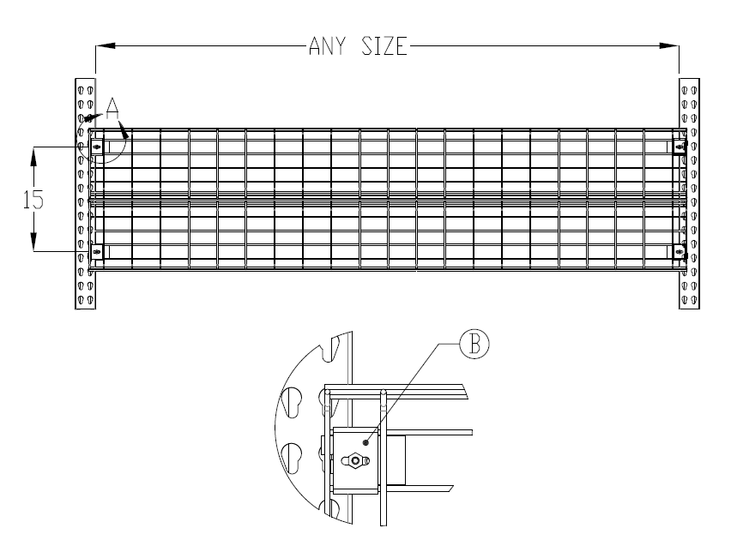

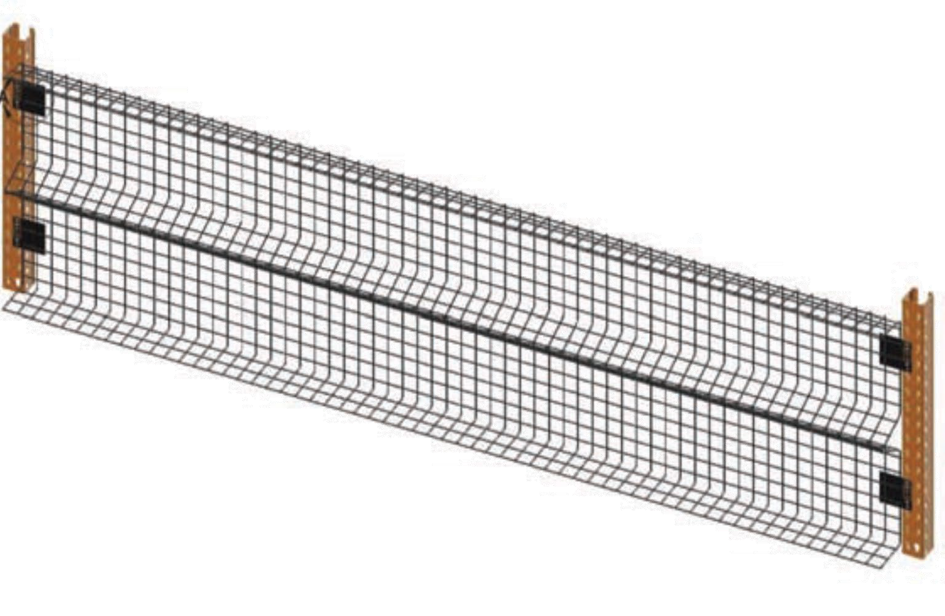
Method 1 Method 2

Pallet Stop Clear Space
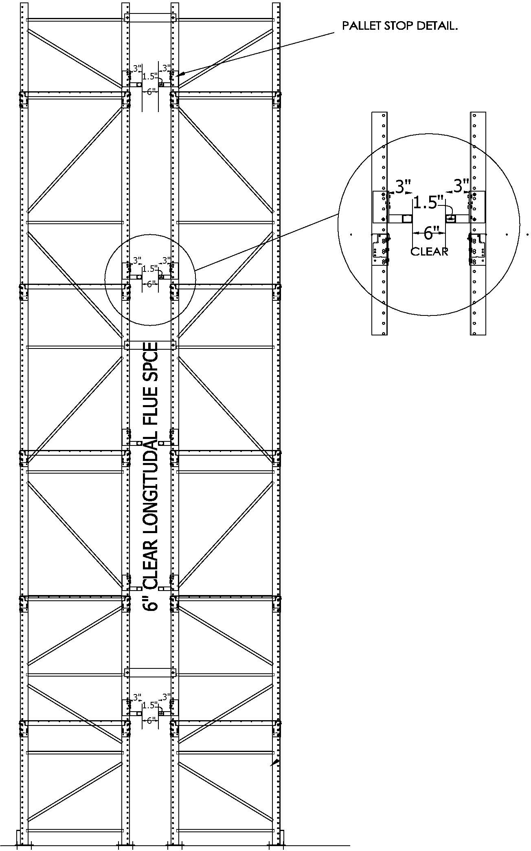

High Pile Storage (HPS) Required Information
The following information shall be completed and copied onto the HPS plans for all projects within EFFPD:

Commodity Classification:
I II III IV High Hazard Group A plastic Commodity detailed
description:

For Group A Plastics where the commodity classification is not High Hazard complete the following: Expanded plastic: Percent by volume: %. Percent by weight: %
Non-expanded plastic: Percent by weight: %
Packaging consists of:

Cartoned Free flowing Non-expanding Encapsulated Non-encapsulated.
Other

The maximum storage height (solid pile rack )
The following storage methods are employed at this facility (mark all that apply): Solid pile storage Palletized
- Single row rack Double row rack Multi-row rack
Other

Rack storage shelf: N/A Load beam only Wire mesh Wood slates Plywood
Other (Describe):
The area designated in the building and used for high piled storage is square feet.
CLASS commodity, sq ft. CLASS commodity, sq ft. CLASS commodity, sq ft.
Smoke vents required No Yes Fusible link degree F.
Draft Curtains Required? Yes NO
The overhead fire sprinkler system utilizes the following heads:
ESFR: K at PSI with Fo heads
Standard Coverage Heads: K Pendant Upright degree with a density of g.p.m. over
square feet spaced at a maximum of square feet per fire sprinkler.
NFPA 13 Design Table: Curve:
Minimum distance between top of storage and sprinkler deflector: Feet

In-rack sprinklers required Yes No
There is/are level(s) of in-rack fire sprinkler protection. Aisle width: feet.
Fire access doors required? Yes (Maximum distance of 125 lineal feet) No
Flue spaces required? Yes No
Flue space between racks shall be maintained a minimum of:
Transverse ” clear. Must be vertically aligned (for storage >25’) Longitudinal ” clear
Column protection required? Yes No
Pallet Stops Required? Yes No Longitudinal flue space protection configuration:
Chain Link Roll Form “C” Channel Other: Transverse flue space protection configuration:
Mechanical means (flue keepers, etc.) Load beam markings “Keep Clear” Hand Stack? No Yes # of tiers: Chain link required No Yes

